**3. Evidence**

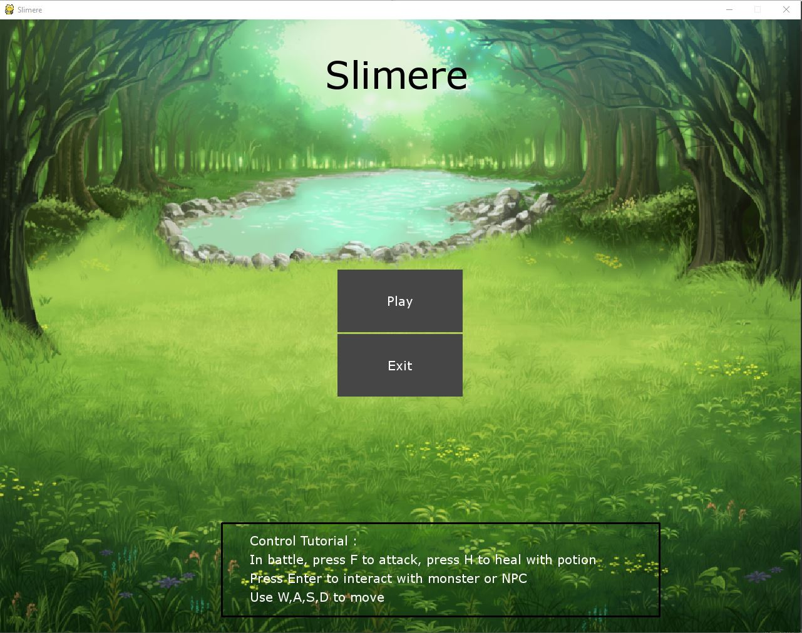

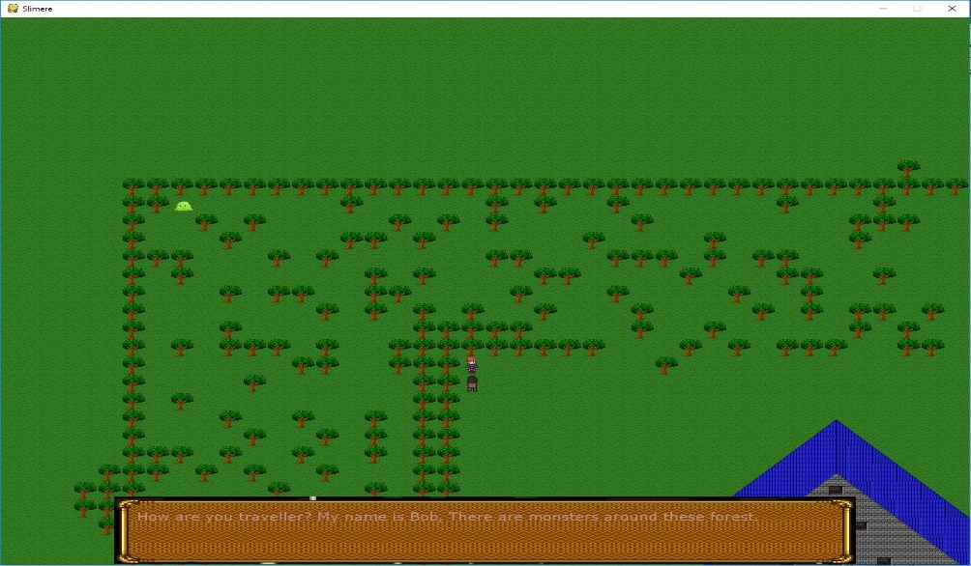

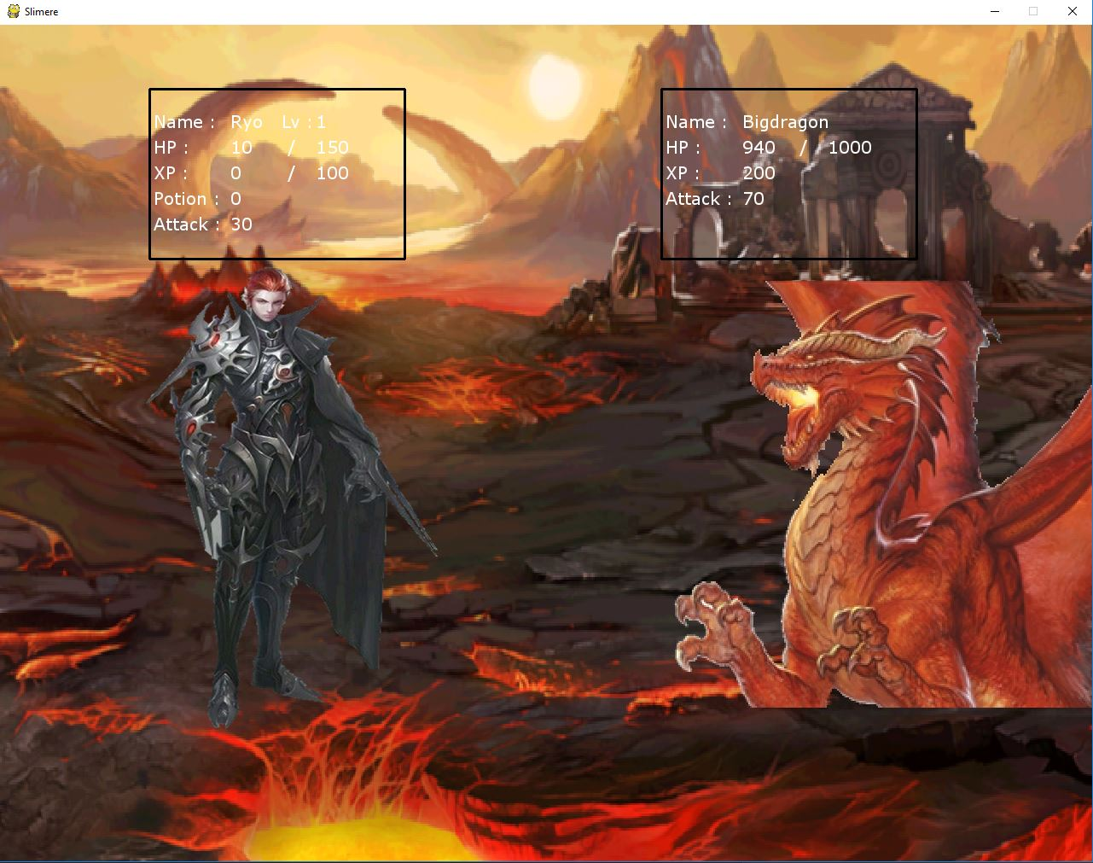

**RPG GAME**

**Name : Ryo Yenata**

**ID : 2201796705**

1. **Description**

This program is a Role Playing Game (RPG) where you grind or get Experience to become more powerful and level-up when reach the amount of Experience needed. You find the monster in the woods and fight them to get Experience. If you level-up, You will get additional Attack and Health Points (HP), but of course, the higher the Level you are, the harder you will be able to actually level-up.

1. **Discussion**

**Implementation:**

The program is used to make this game is Python 3.7.0, it is the latest version of Python. I also use the Pygame 1.9.4 Package, which is the latest version of Pygame. The pygame package is what makes this game possible, because it is especially made to make game in python.

Pygame comes with many function and tools to make it easier to make games in Python.

**How the game works?**

When the program starts, you will be directed to the Main menu, It will show you the controls and the Goal of the game. You can either Start or Quit the game in the Main menu.

**How to win the game?**

You will need to beat the Boss of the game. It is not easy to win the game, because the Boss will have really high stats, and you will need to level-up to actually be able to defeat the boss. By leveling-up, you will get a HP boost and an Attack boost, by every level you level-up, you will get 1 Healing potion to help you and it will heal-up your HP to the Maximum amount of HP.

**How to lose the game?**

You will lose if your character reaches 0 HP and you will be directed to the Lose screen.

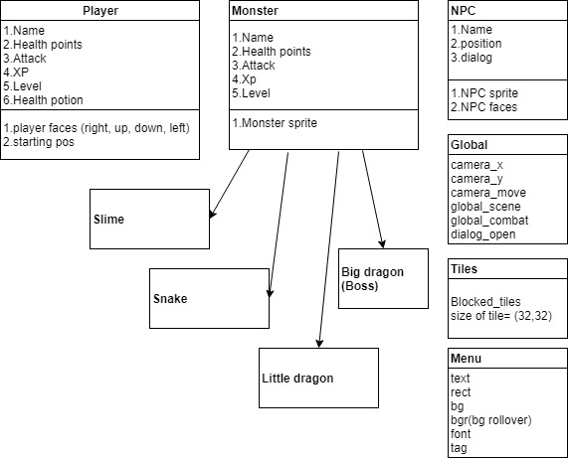



**BINUS UNIVERSITY**

**BINUS INTERNATIONAL**

**Assignment Cover Letter**

**(Individual Work)**

|  |  |  |  |  |  |  |  |  |
| --- | --- | --- | --- | --- | --- | --- | --- | --- |
|  | | | | |  | |  | |
| **Student Information**: **Surname** | | | | | **Given Name**  Yenata | | **Student ID Number**  **2201796705** | |
| 1. | | **Ryo** |  | |
|  |  |
| **Course Code** | **: COMP6335** |  |  | | **Course Name** | | **: Introduction to Programming** | |
| **Class** | **: L1AC** |  |  | | **Name of Lecturer(s)** | | : Minaldi Loeis | |
|  |  |  |  | |  | |  | |
| **Major** | **: CS** |  |  | |  | |  | |
| **Title of Assignment**  (if any) | : RPG game | |  |  | |  | |  | |
| **Type of Assignment**    **Submission Pattern** | **: Final Project** |  |  | |  | |  | |
| **Due Date** | **: 21-11-2018** |  |  | | **Submission Date** | | **: 21-11-2018** | |

# Plagiarism/Cheating

BiNus International seriously regards all forms of plagiarism, cheating and collusion as academic offenses which may result in severe penalties, including loss/drop of marks, course/class discontinuity and other possible penalties executed by the university. Please refer to the related course syllabus for further information.

# Declaration of Originality

By signing this assignment, I understand, accept and consent to BiNus International terms and policy on plagiarism. Herewith I declare that the work contained in this assignment is my own work and has not been submitted for the use of assessment in another course or class, except where this has been notified and accepted in advance.

Signature of Student: 1. Ryo yenata

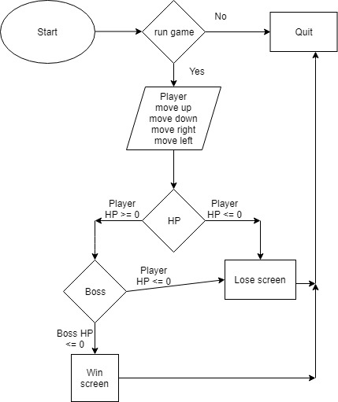

Resources / References:

Livander Surya

<https://www.pygame.org/project/184> (art reference)

Google (art reference)

Youtube (Channel = Meloonatic Melons) RPG Tutorial

<https://www.youtube.com/playlist?list=PL_lFlMpDYWjGRtfO8dawgZUvMdcmtKRoV>